Institute of Computer Technology

B. Tech Computer Science and Engineering

Subject: DBMS (2CSE301)

MIDSEM – 1

**PRACTICAL-EXAM**

**Aim: Practical Definition**

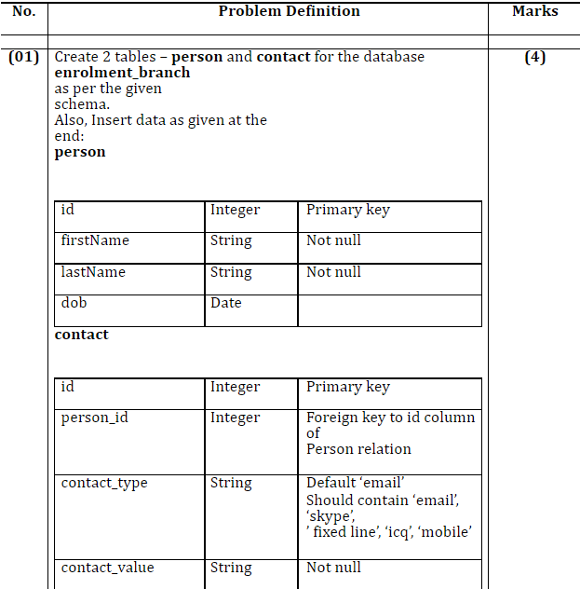

***QUERY (Table 1 - person)***

CREATE TABLE person(id INT PRIMARY KEY, firstName VARCHAR(20) NOT NULL, lastName VARCHAR(20) NOT NULL, dob DATE);

***OUTPUT***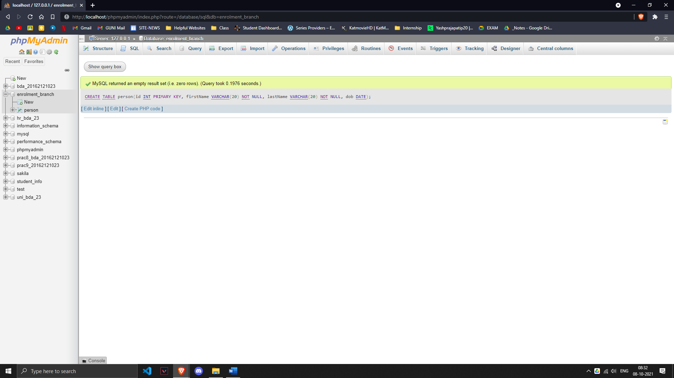

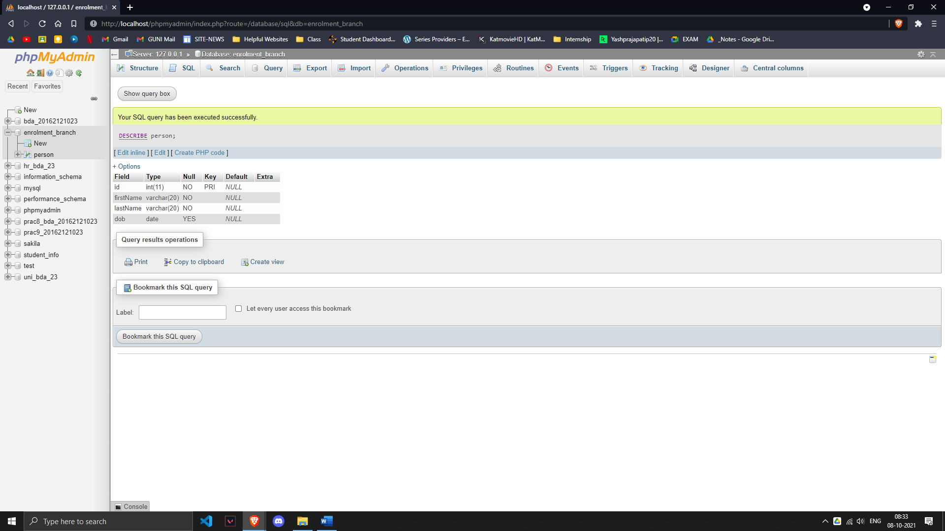

***QUERY (Table 2 - contact)***

CREATE TABLE contact(id INT PRIMARY KEY,person_id INT, contact_type VARCHAR(20) DEFAULT 'email' CHECK(contact_type IN('email','skype','fixed line','icq','mobile')), contact_value VARCHAR(20) NOT NULL, FOREIGN KEY(person_id) REFERENCES person(id));

***OUTPUT***

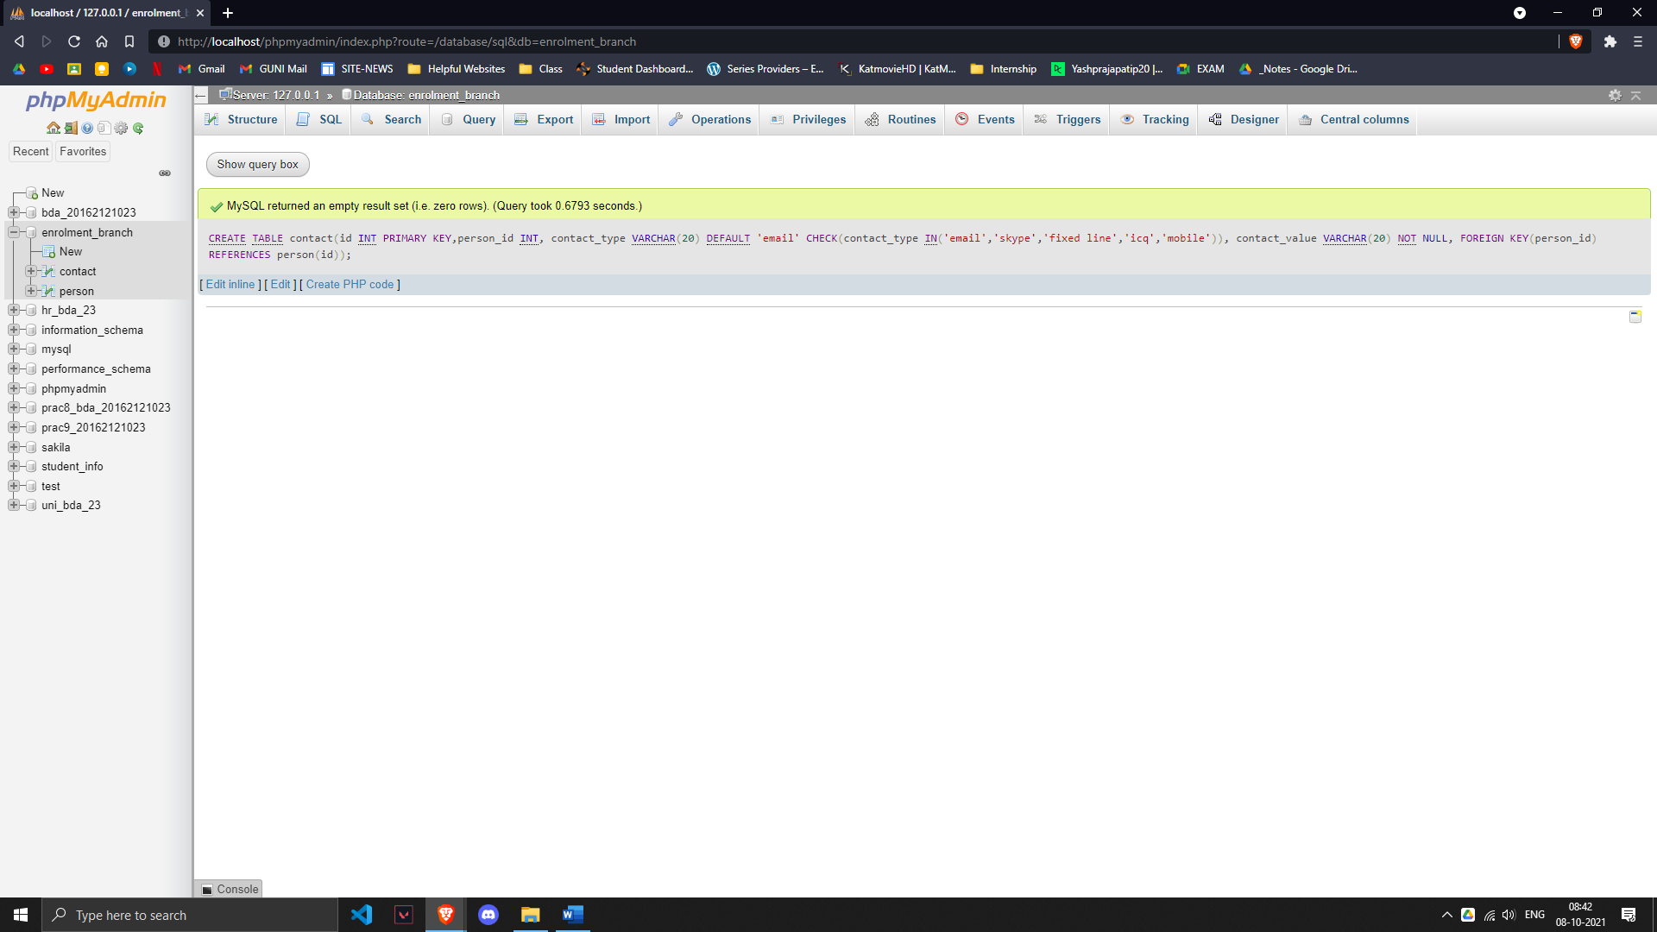

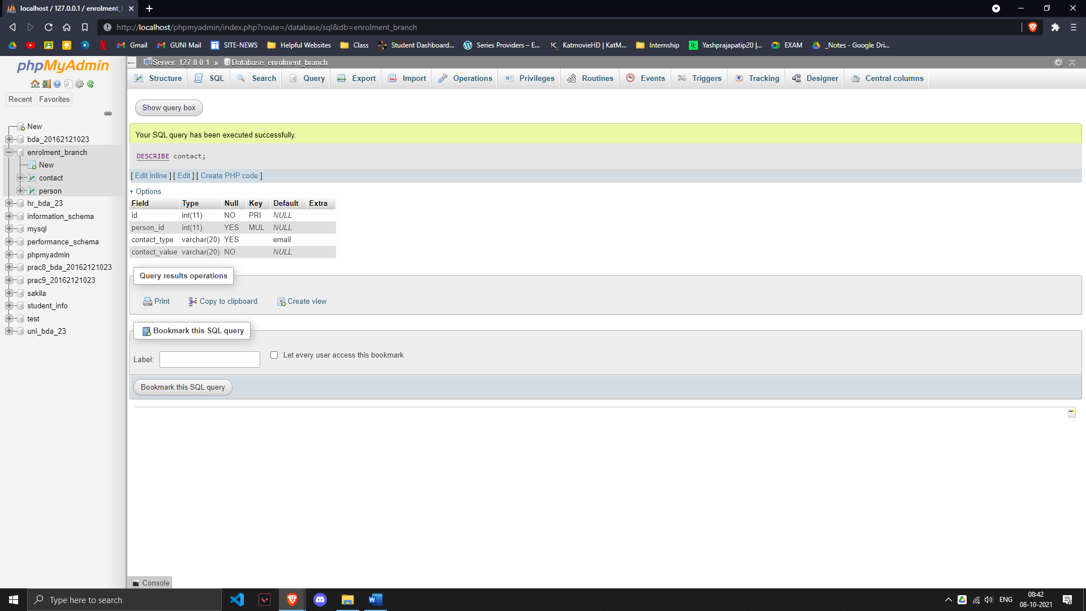

**DATE VALUES: -**

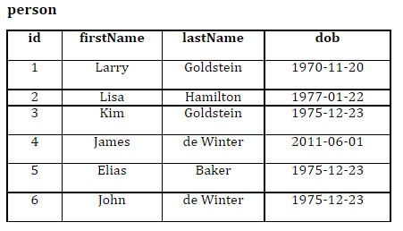

***QUERY (Data of Table 1- person)***

INSERT INTO `person`(`id`, `firstName`, `lastName`, `dob`) VALUES ('1','Larry','Goldstein','1970-11-20');

INSERT INTO `person`(`id`, `firstName`, `lastName`, `dob`) VALUES ('2','Lisa','Hamilton','1977-01-22');

INSERT INTO `person`(`id`, `firstName`, `lastName`, `dob`) VALUES ('3','Kim','Goldstein','1975-12-23');

INSERT INTO `person`(`id`, `firstName`, `lastName`, `dob`) VALUES ('4','James','de Winter','2011-06-01');

INSERT INTO `person`(`id`, `firstName`, `lastName`, `dob`) VALUES ('5','Elias','Baker','1975-12-23');

INSERT INTO `person`(`id`, `firstName`, `lastName`, `dob`) VALUES ('6','John','de Winter','1975-12-23');

***OUTPUT (Table 1)***

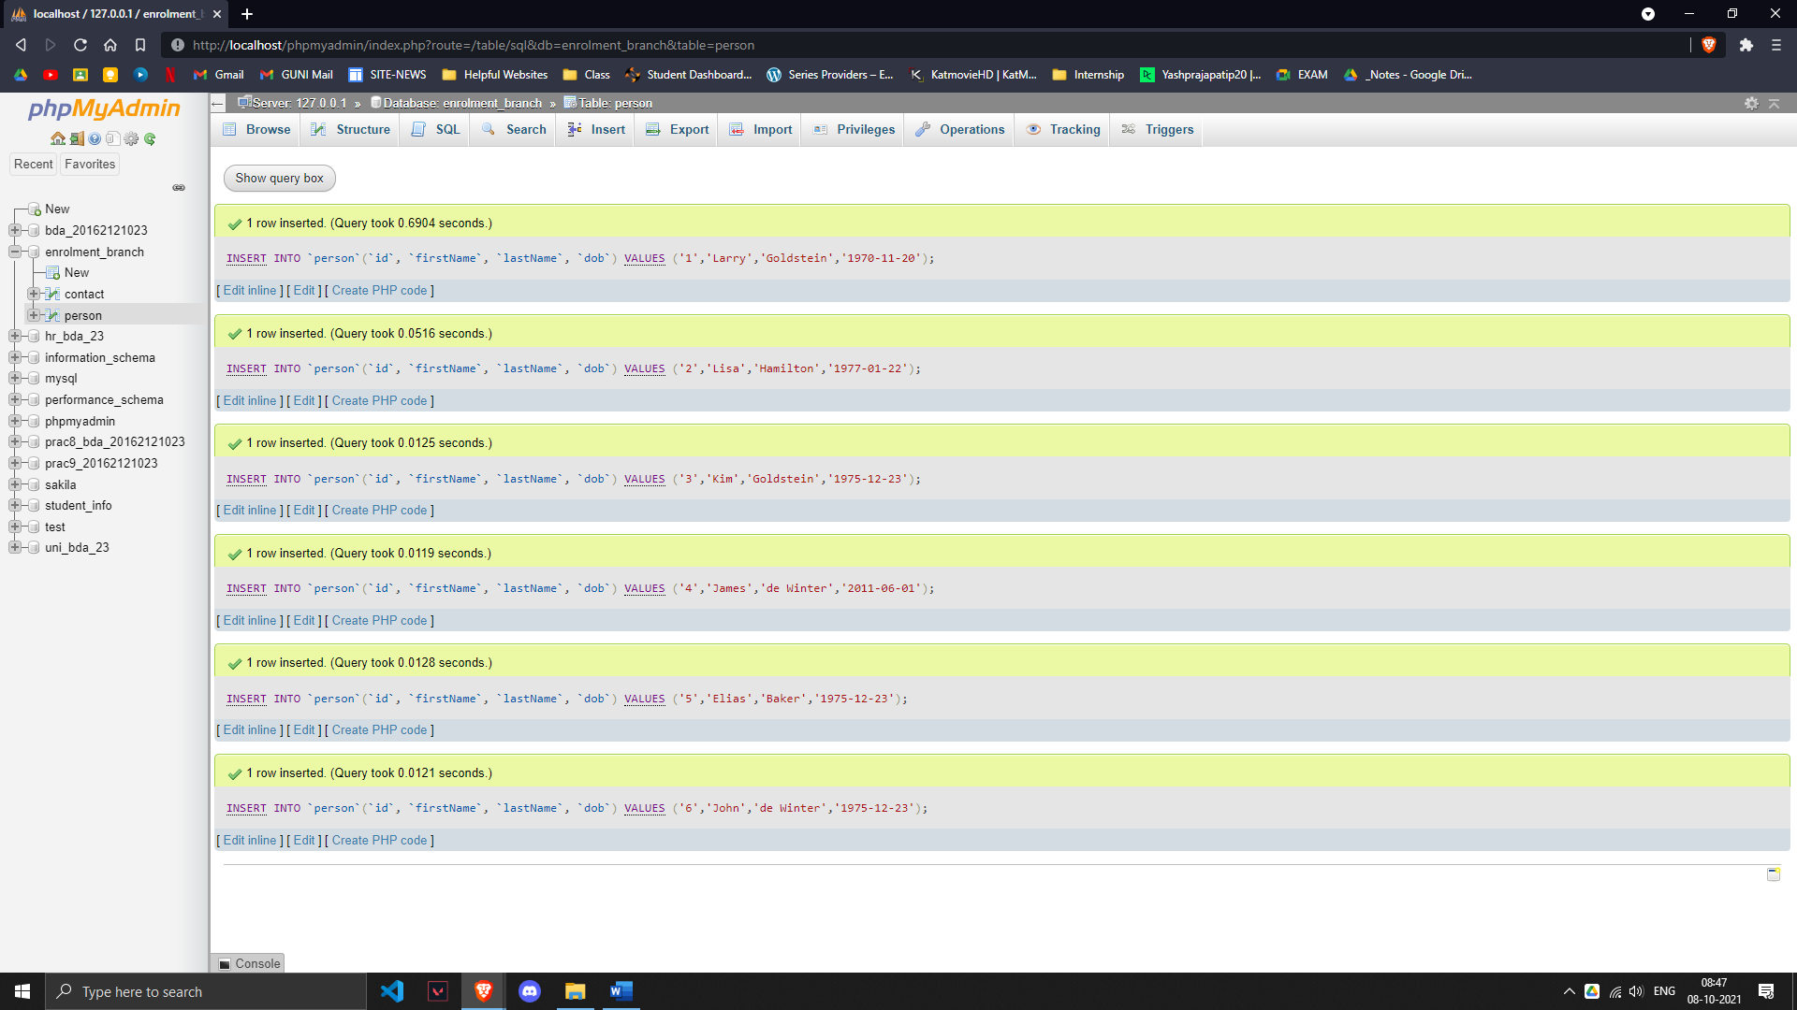

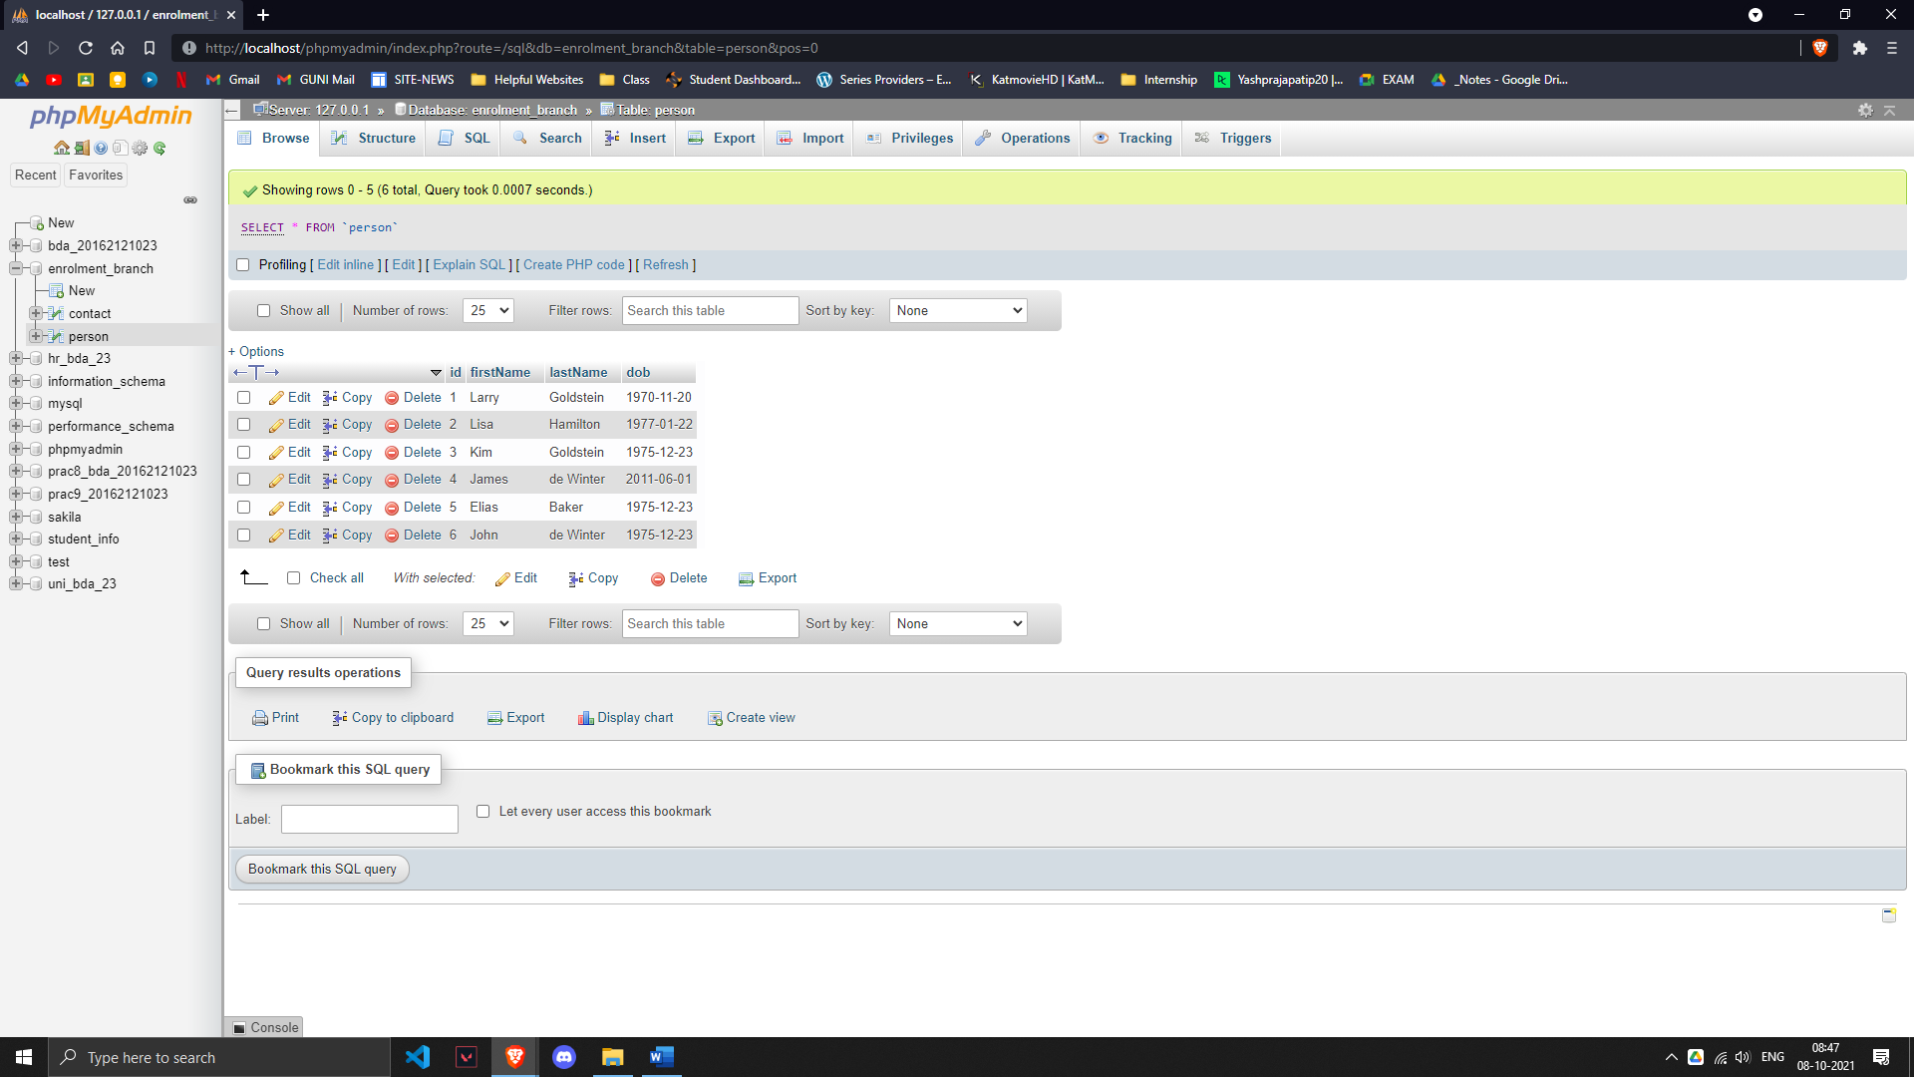

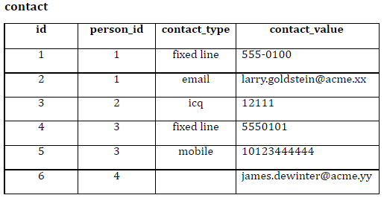

***QUERY (Data of Table 2- person)***

INSERT INTO `contact`(`id`, `person_id`, `contact_type`, `contact_value`) VALUES ('1','1','fixed line','555-0100');

INSERT INTO `contact`(`id`, `person_id`, `contact_type`, `contact_value`) VALUES ('2','1','email','larry.goldstein@acme.xx');

INSERT INTO `contact`(`id`, `person_id`, `contact_type`, `contact_value`) VALUES ('3','2','icq','12111');

INSERT INTO `contact`(`id`, `person_id`, `contact_type`, `contact_value`) VALUES ('4','3','fixed line','555-0101');

INSERT INTO `contact`(`id`, `person_id`, `contact_type`, `contact_value`) VALUES ('5','3','mobile','10123444444');

INSERT INTO `contact`(`id`, `person_id`, `contact_value`) VALUES ('6','4','james.dewinter@acme.yy');

***OUTPUT (Table 2)***

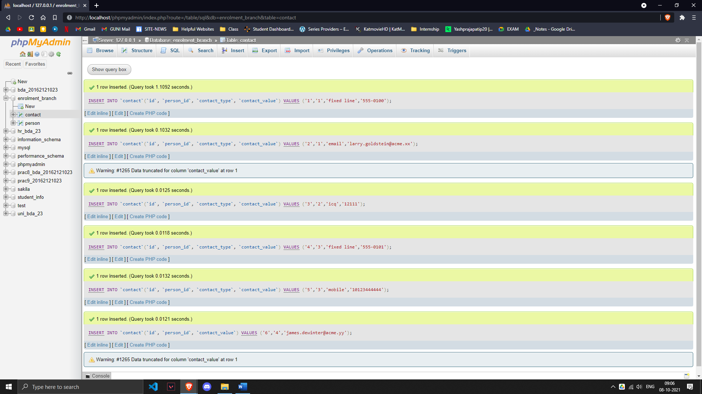

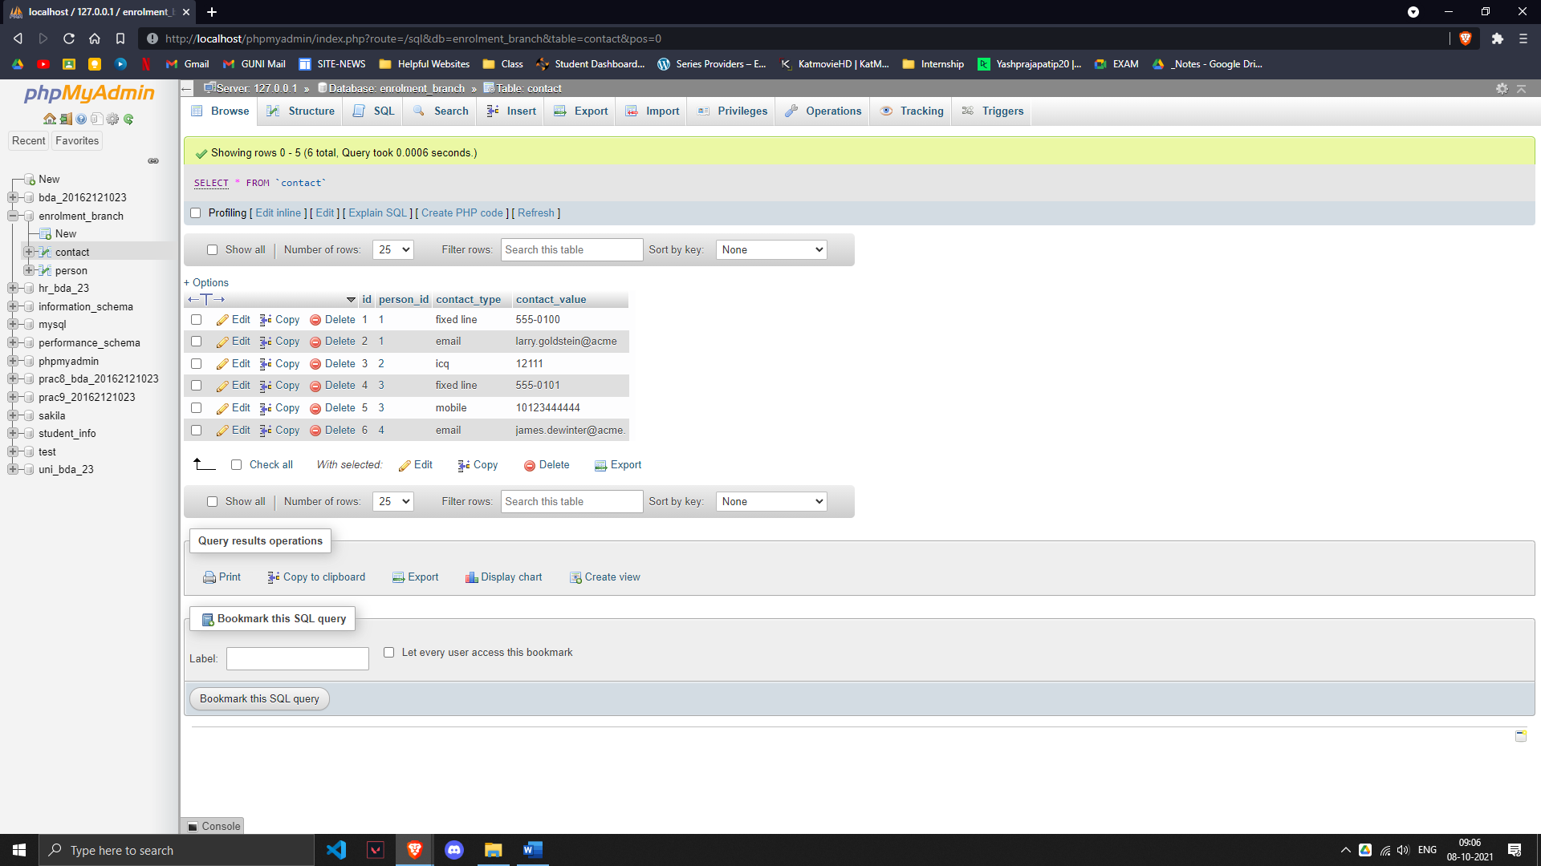

**Questions: -**

**Q2. Display All the details of people whose contact details are not available. (2)**

***QUERY***

SELECT * FROM person LEFT JOIN contact ON person.id=contact.person_id;

***OUTPUT***

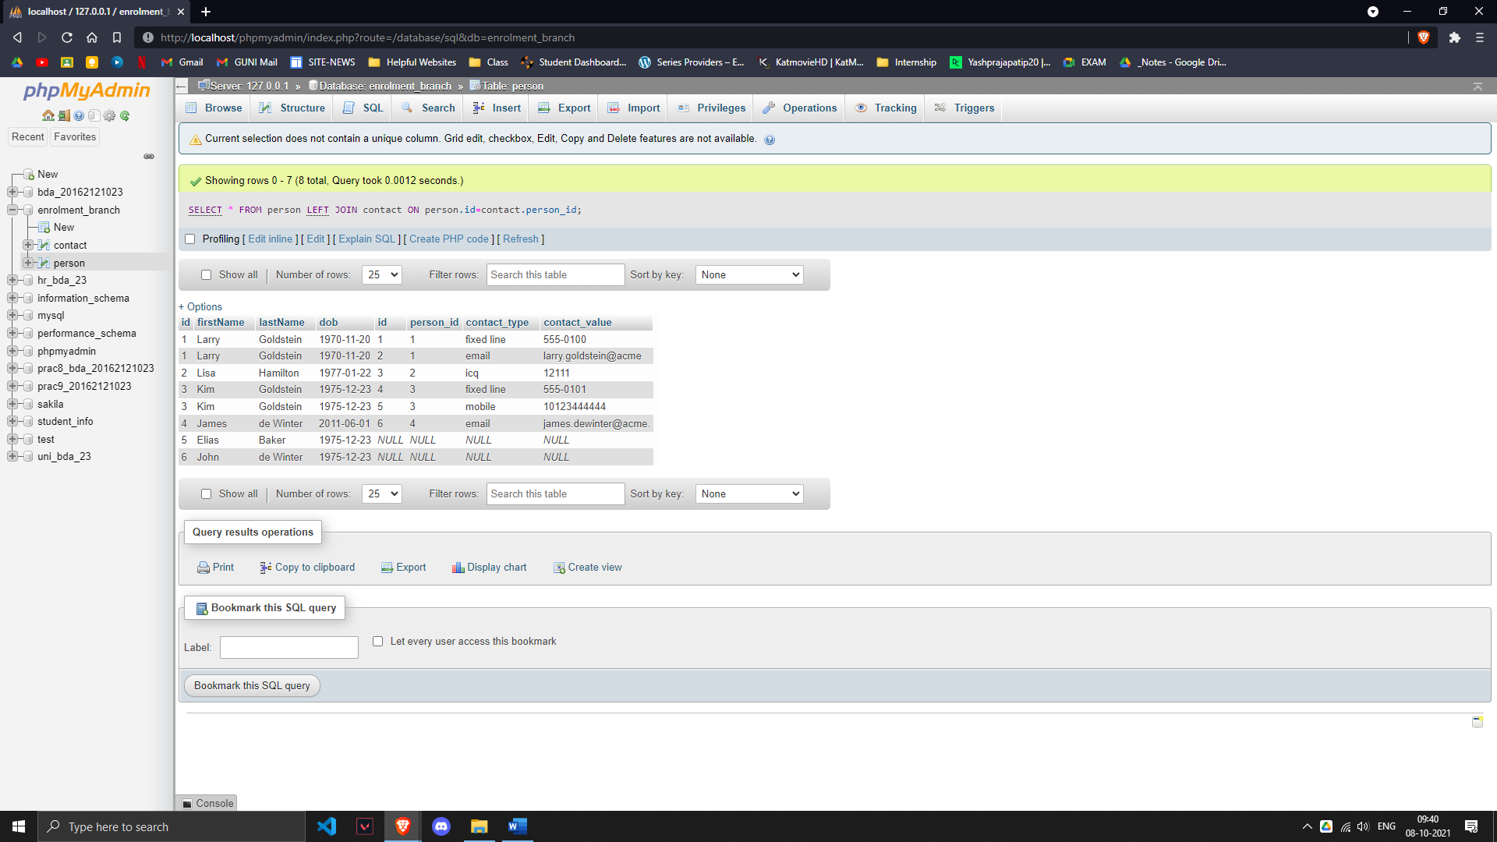

**Q3. Display person_id and total count of his/her contact type. (2)**

***QUERY***

SELECT `person_id`,count(contact_type) FROM `contact` GROUP BY `person_id`;

***OUTPUT***

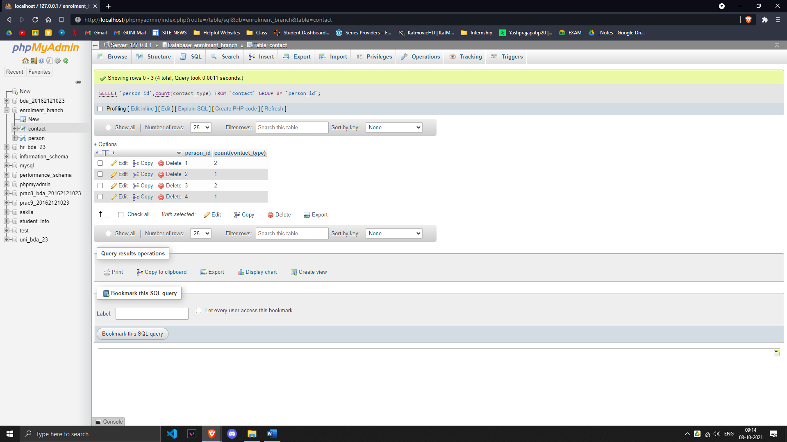

**Q4. Display the contact details of the people who are born in December month in the descending order of their last name. (3)**

***QUERY***

SELECT * FROM person INNER JOIN contact ON person.id=contact.id WHERE person.dob LIKE '%12%' ORDER BY person.lastName DESC;

***OUTPUT***

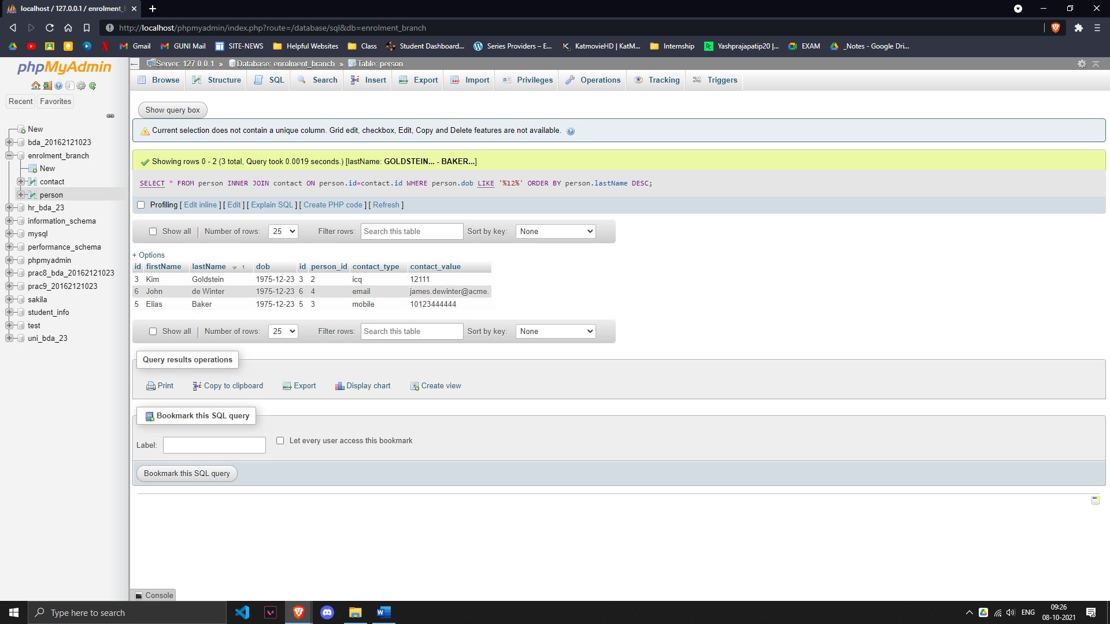

**Q5. Rename the table contact to ‘contact_info’. (1)**

***QUERY***

ALTER TABLE contact RENAME TO contact_info;

***OUTPUT***

